**Steps to follow to be up-to-date with what I do from this side.**

1. Click on the GitHub link I sent to view my current Commit (*A commit is like a time stamp/backup of the project. It allows us to go directly to when a specific change was made to the project. In our case, when a specific feature is implemented*)

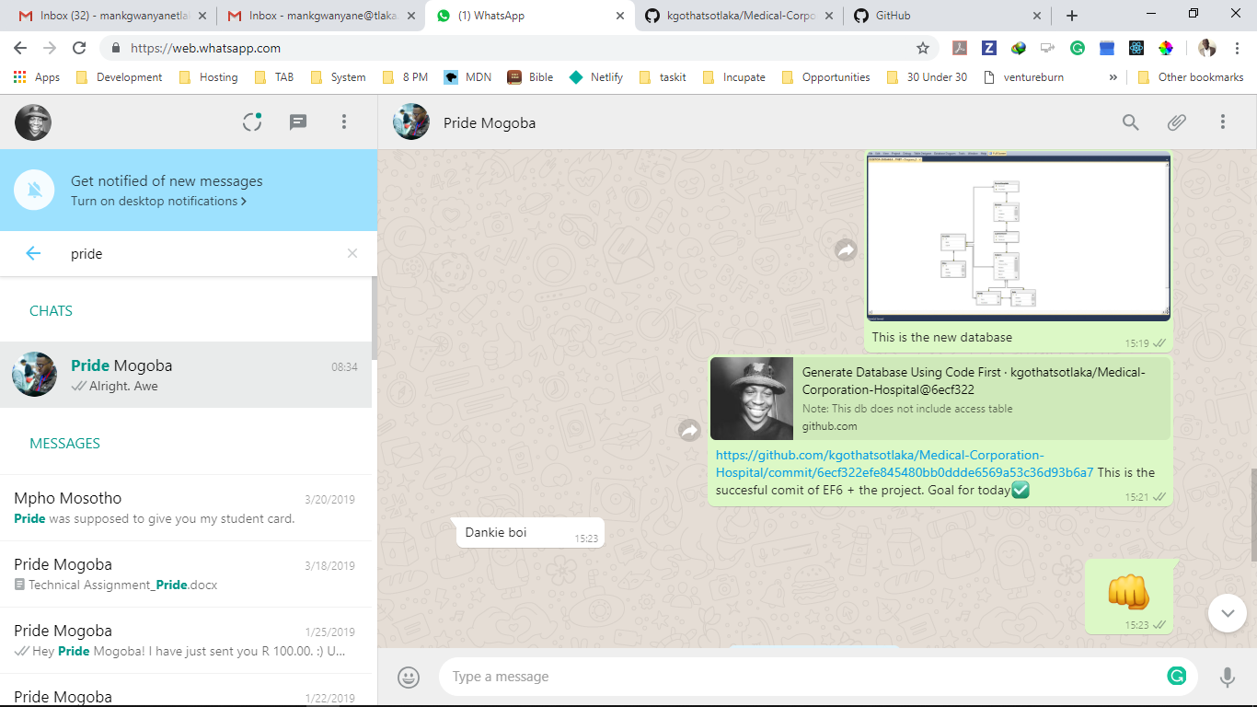

1. Once you get to the commit, as shown below. You will notice the following:
   1. The name of the commit: this is usually the change that I just did, e.g. “Create Dd Using EF6”

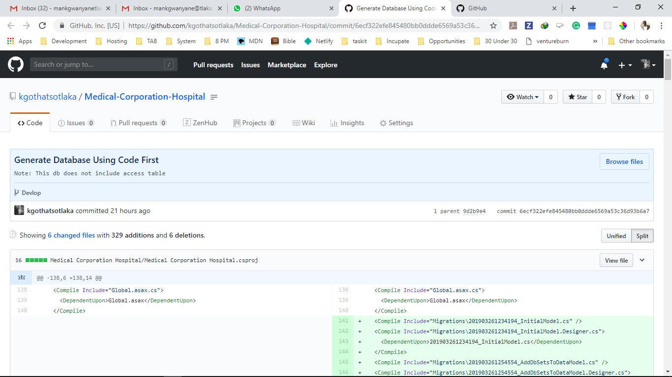

* 1. Below is the name of the changes made to the project, I use split view to see the files modified. Red Shows the lines which are removed and Green for the lines that I added.

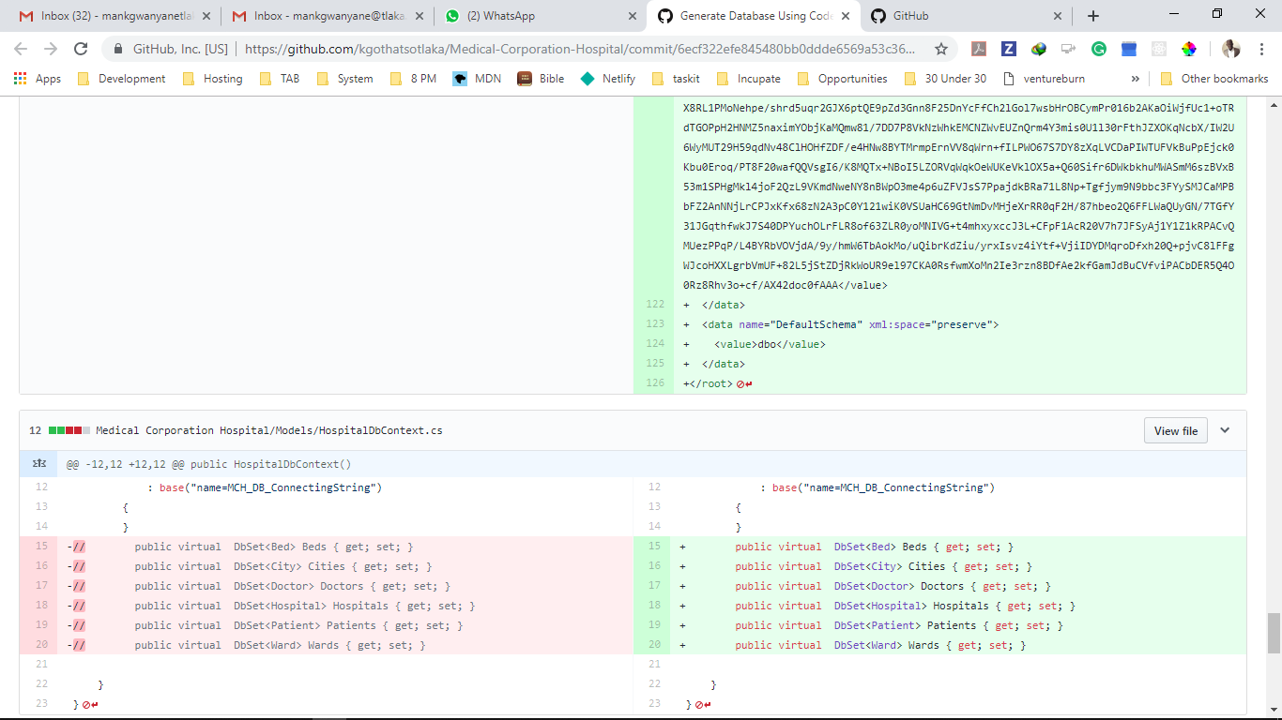

* 1. Click on the project link “Medical-Corporation-Hospital”, as shown below. This will take you to the home of the repo, the master branch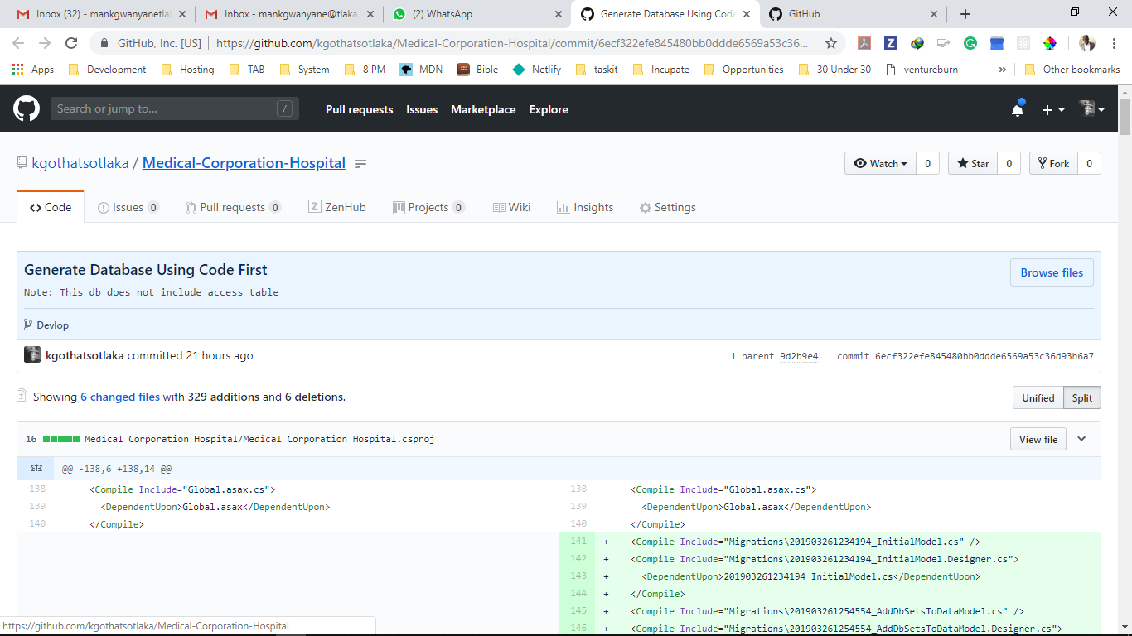
  2. Once you get to the home page, navigate from master branch to Develop Branch as shown below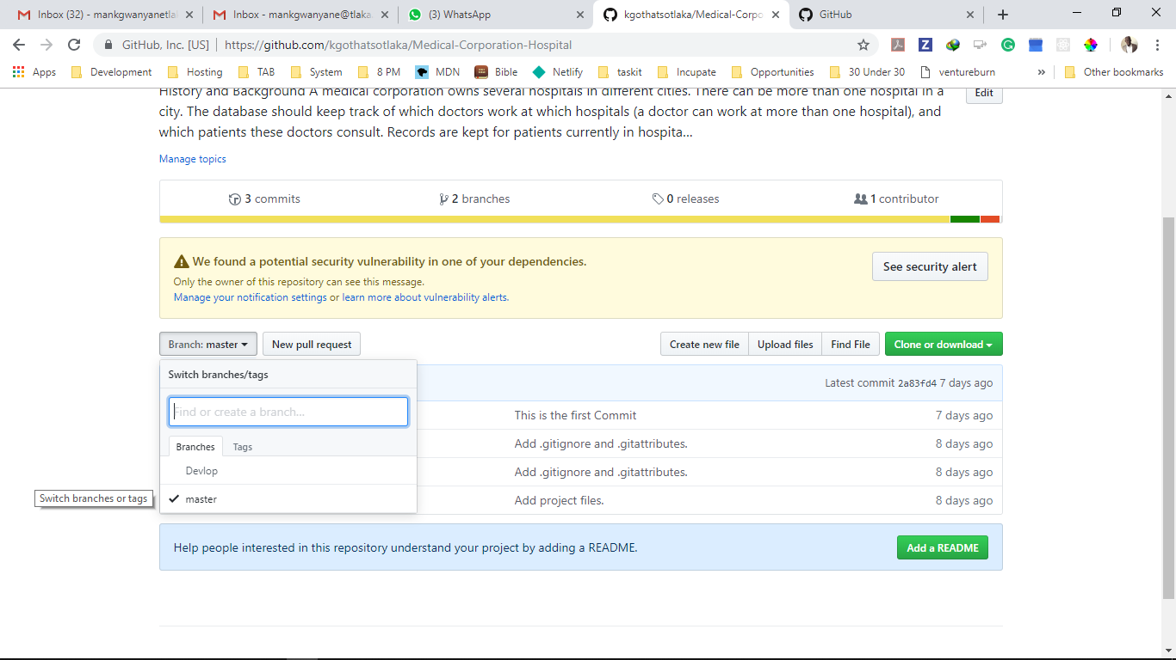
  3. Confirm that you are in the correct Branch as shown below

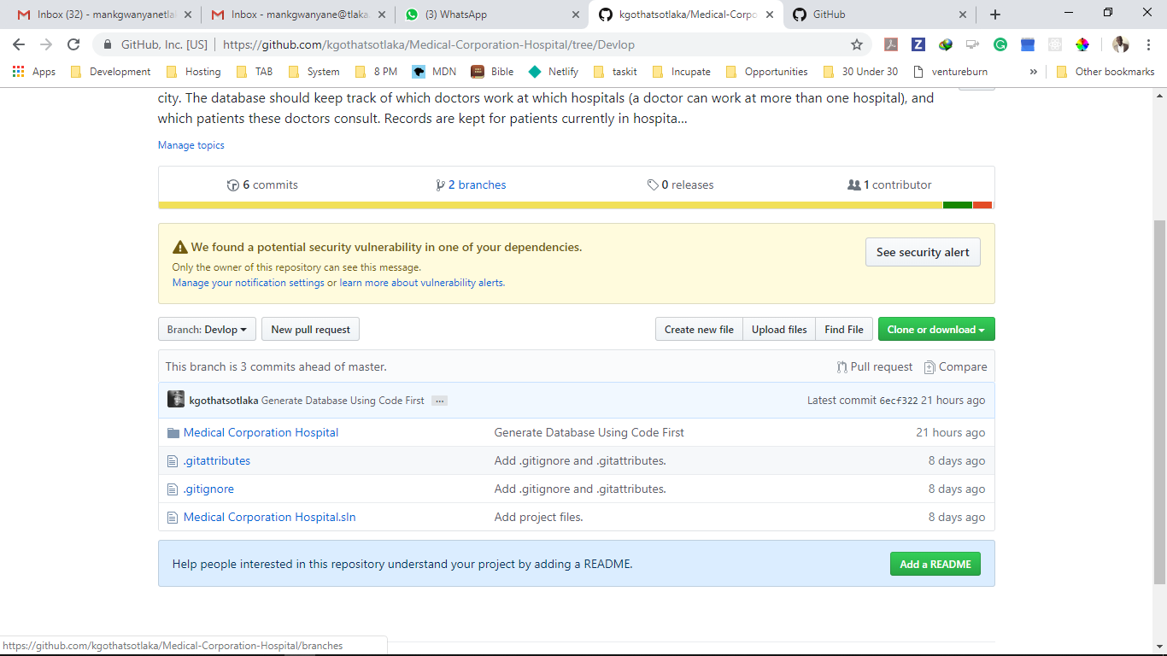

* 1. Click on Download or Clone as shown below

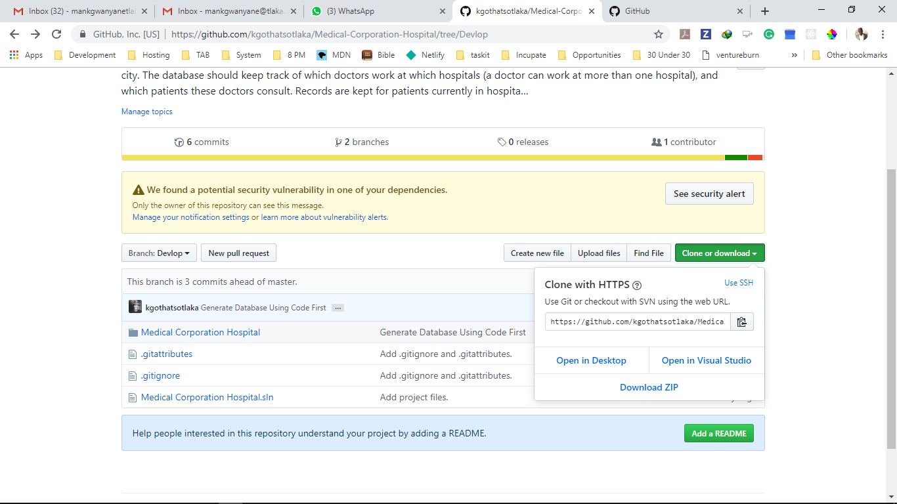

From there you can download as Zip. Then open the ProJet on your local machine.

I would suggest you download and install GitHub For Desktop

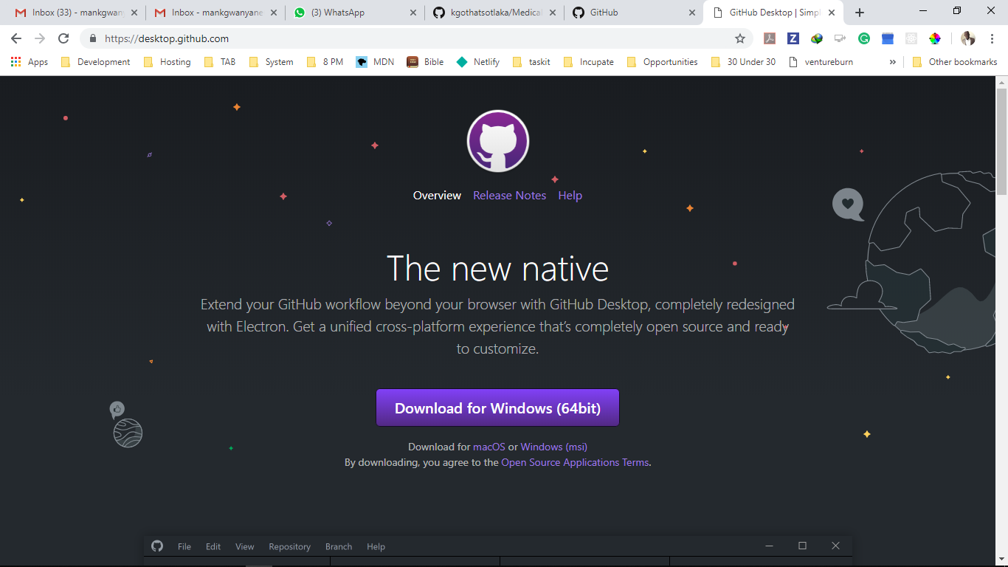

This will make things a lot easier. It will also ensure that you are aware of every change I need and have the up to date files without having to do all the above-mentioned steps. Please ask me to clarify any part you don’t understand